**Developer Candidate Assignment**

# PROBLEM #1

Given the following interface:

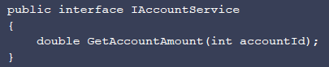

...and the following class that depends on this interface:

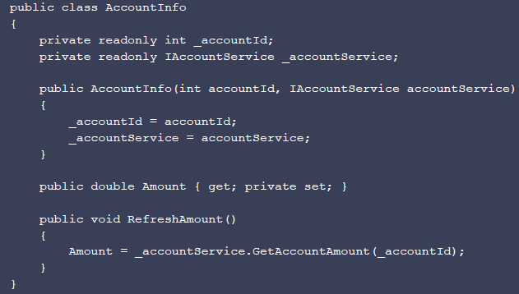

REQUIRED: Write a unit test that asserts the behaviour of RefreshAmount() method.

# PROBLEM #2

It has been determined that IAccountService.GetAccountAmount() is a potentially slow and unreliable remote network call and that it should be made asynchronous. Note that

AccountInfo.RefreshAmount() may be invoked multiple times concurrently. Adjust IAccountService and / or AccountInfo and your tests accordingly.

# PROBLEM #3

Write a build script. Consider compilation, test execution and producing a nuget package.